# Study material for SKILLS LAB

Student Name: Paco Puylaert (15123022)

Class: 1a

* Lynda.com

HTML essential training.

<https://www.lynda.com/HTML-tutorials/HTML-Essential-Training/170427-2.html>

(From here I learned the very basics. The main tags and how to structure the page)

* I learned basic html syntax that I used all over the code.
* What the head is and what the body is.
* How to emphasize text
* The aside element even though I did not needed it on my code.
* The div element
* Linking to external pages
* Unordered list
* How to create inline styles

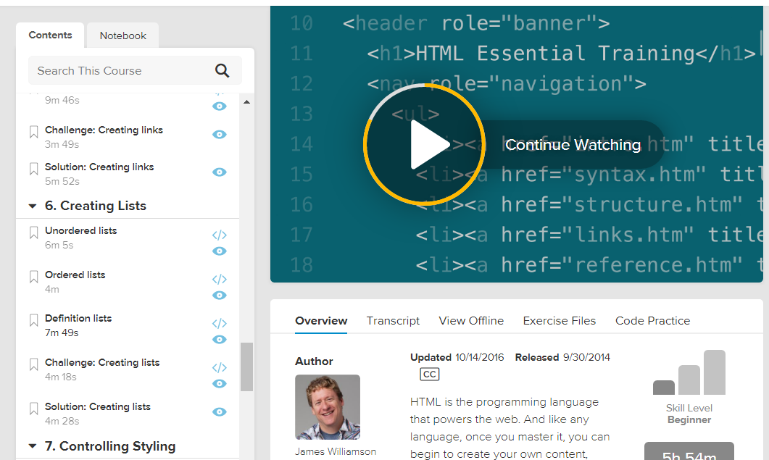

* YouTube

HTML and CSS Tutorial for Beginners | The Ultimate guide to learning HTML and CSS

<https://www.youtube.com/watch?v=y3UH2gAhwPI>

This tutorial explained similar things than the Lynda.com one. However, the talker is very funny, which made it a pleasure to listen to. He utility of this video was that it strengthened my understanding because it was not the first time anymore I was hearing related vocabulary to coding.

* Codeacademy

<https://www.codecademy.com/>

I did the first exercises to start getting a firmer grasp on topics. This helped me to gain confidence in applying the main functions of html.

(From here I took notes about every single part of the process. Started understanding how to apply some styles to the page)

* Classmate:

Michal Maciejewski

(Michael took the time to explain me how to structure effectively the folder in order to make the code work. Furthermore, he helped me clarifying how I wanted my website to look. He expalined the order in the thinking process and the way to approach coding, which in his opinion, is constant "problem solving" , use of logics, and googling to gain more knowledge. I was working on my website and had him aside explaining how to do one specific thing that I could repeat through all the website and really understand. Michael tought me how to connect the html files to the css and explained how each element on the page should be positioned to be have a visually appealing website.) Michal explained me:

* How to structure effectively the folders
* How to start the codes and how to name each related code
* Which sites to take inspiration from and good suggestions
* How to structure the code to make it easier to read (even though I believe it is not perfect everywhere)
* How to use padding and margins effectively
* How to position elements on the page
* How to use fonts taken from google
* How to style the elements
* How to use classes
* W3School

I used W3 School for many different features I wanted to add to the website

<https://www.w3schools.com/graphics/google_maps_intro.asp> Google maps.

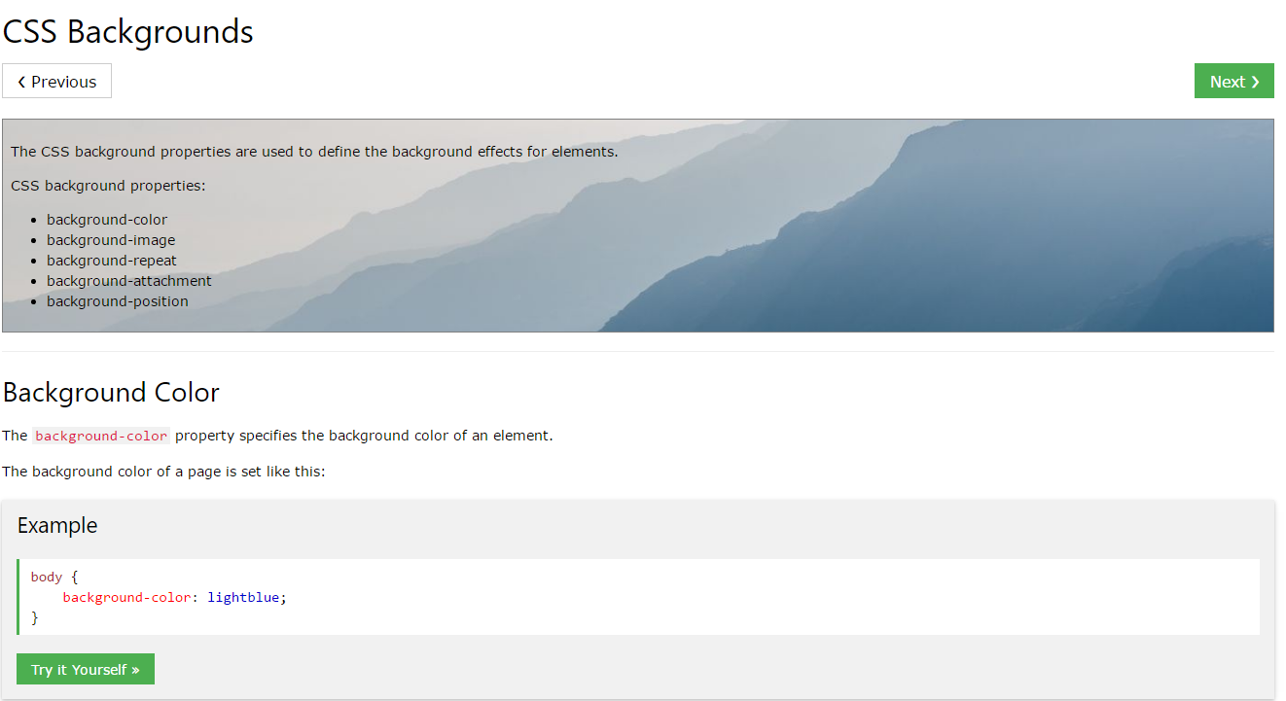

I used this information to apply a map to the contact page to show where I was born.

<https://www.w3schools.com/html/html_youtube.asp> YouTube.

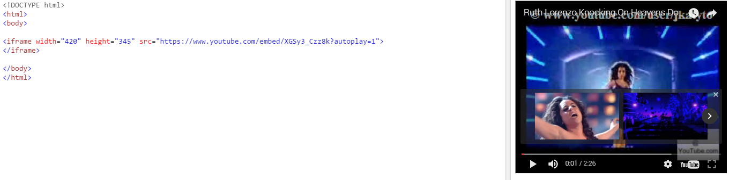

I used this to put a video in the index where I show what I mainly do and to show my first project’s video. To do this I had to upload first the videos on YouTube and then link them.

<https://www.w3schools.com/tags/tag_img.asp> Img tag.

I used this tag to put the logotype on multiple locations of the webpage.

<https://www.w3schools.com/html/html_headings.asp> headings

I used this link to understand how the different headings are. After that I applied them to the page.

<https://www.w3schools.com/html/html_links.asp> links

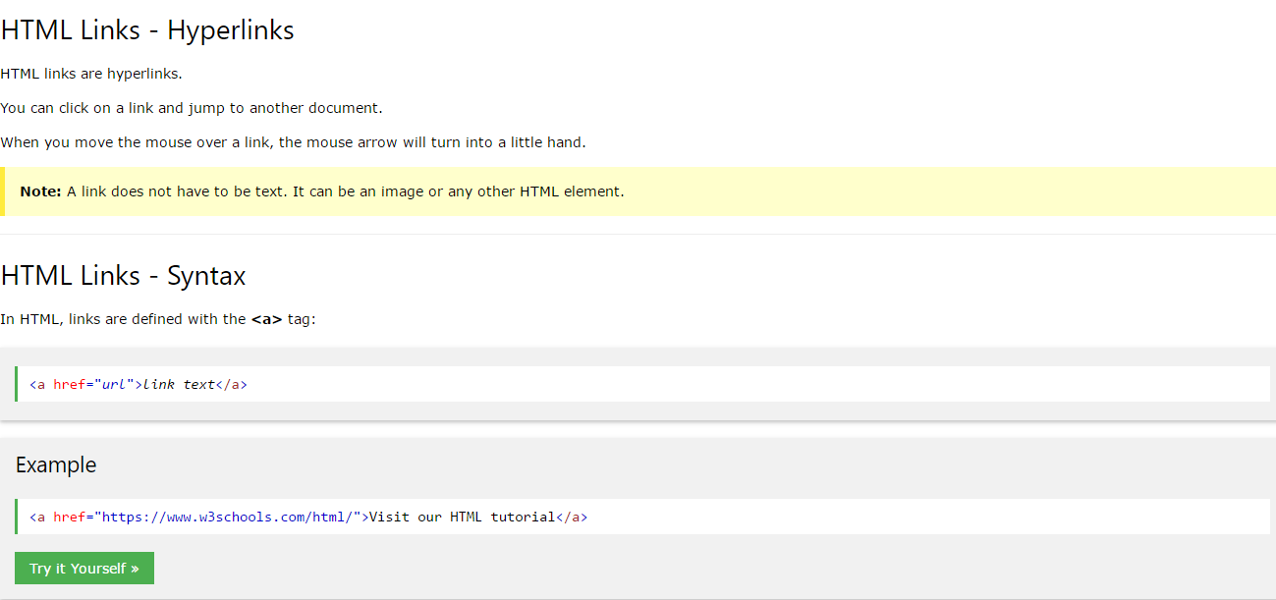

I used links to make the clickable images on the contact page, where from clicking on the icons of Instagram and Facebook you automatically get redirected to my social media pages. Links have been used as well to link each page to the other pages.

<https://www.w3schools.com/html/html_images.asp> images

Images are a core part of my website. I am showing my projects on the website and to do that I needed to know how to put an image on the website.

<https://www.w3schools.com/html/html_lists.asp>

I needed to make lists in the website. One for the header and one for the footer and even for the images. W3Schpool thought me how to.

<https://www.w3schools.com/css/css_background.asp>

Since I have a background on my website composed of an image, I needed to understand how to set that appropriately and I learned that on W3 school and through help of Michal.

I learned the basics of HTML and CSS. It took a very long time to start "connecting the dots" of what I was learning. Even though I really was trying to whatch tutorials and make sense out of them, without the help of my classmate Michal I would have not been able to learn the basics I now retain to have. The learning process has been:

# Overall time spent

Overall 12 hours of tutorials

Overall 20 hours trying things without obtaining decent results

Overall 20 hours of coding with guidance from classmate when needed.

Overall 2 hours asking questions about "obvious" topics in the field of coding that for me where everything but obvious.

# The Process and reflection

Initially, the approach to the process was based on watching tutorials. I honestly started more tutorials than the ones cited above. However, I stopped the process because of the feeling of not being capable of repeating it myself. In two terms time I got the luck to ask more skilled people how they approach the entire process. And that has demonstrated to be the best way to learn. By phisically watching others doing and by asking hem how and why.

I consider my self to have been annoying to my classmates in more situations but I really believe that is the best way to learn. I suggest to give lectures where students are hands on from the beginning with calm guidance from the professors. I was not able to ask questions during classes because I did not know what to ask or even how to ask. Even though that I understand that professors gave availability to students and appreciate that.

Learning coding is a long process and I am just t the beginning of it. Now I am able to understand tutorials and I will go on with them.